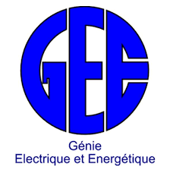

Measurement and Instrumentation

Report

Solar Charge Controller

SOU chenrith

E20170875

lectured BY:

CHEA KIMSAIRNG

ENGINEERING’S DEGREE

DEPARTMENt OF eLECTRONIC AND ENERGY ENGINEERING

INSTITUTE OF TECHNOLOGY OF CAMBODIA

PHNOM PENH

2019-2020

# Solar Charge Controller

## Introduction to Solar

### History of solar

Though solar energy has found a dynamic and established role in today’s clean energy economy, there’s a long history behind photovoltaics (PV) that brought the concept of solar energy to fruition. In theory, solar energy was used by humans as early as 7th century B.C. when history tells us that humans used sunlight to light fires with magnifying glass materials. Later, in 3rs century B.C., the Greeks and Romans were known to harness solar power with mirrors to light torches for religious ceremonies.

In the late 1700s and 1800s, researchers and scientist has success using sunlight to power ovens for long voyages. They also harnessed the power of the sun to produce solar-powered steamboats. The development of solar panel technology was an iterative one that took a number of contributions from various scientists. This breakthrough, defined as the “photovoltaic effect” was influential in later PV developments with the element selenium. In 1873, **Willoughby Smith** discovered that selenium had photoconductive potential, leading to **William Grylls Adams’s** and **Richard Evans Day’s** 1876 discovery that selenium created electricity when exposed to sunlight. A few year later in 1883, **Charles Fritts** actually produced the first solar cells made from selenium wafers the reason some historians credit **Fritts** with invention of solar cells.

However, solar cells as we know them today are made with silicon, not selenium. Therefore, some consider the true invention of solar panels to be tied to **Daryl Chapin**, **Calvin Fuller**, and **Gerald Pearson**’s creation of the silicon photovoltaic (PV) cell at the **Bell** lab 1954.

Many argue that this event marks the true invention of PV technology that could actually power an electric device for several hours of a day. The first ever silicon solar cell could convert sunlight at four percent efficiency, less than a quarter of what cells are capable of.

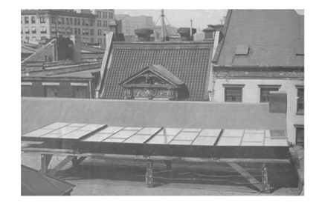

Figure 1: Charles Fritts first solar photovaliac array in New York in 1884